**Output1 – Class diagram which contain classes and associations**

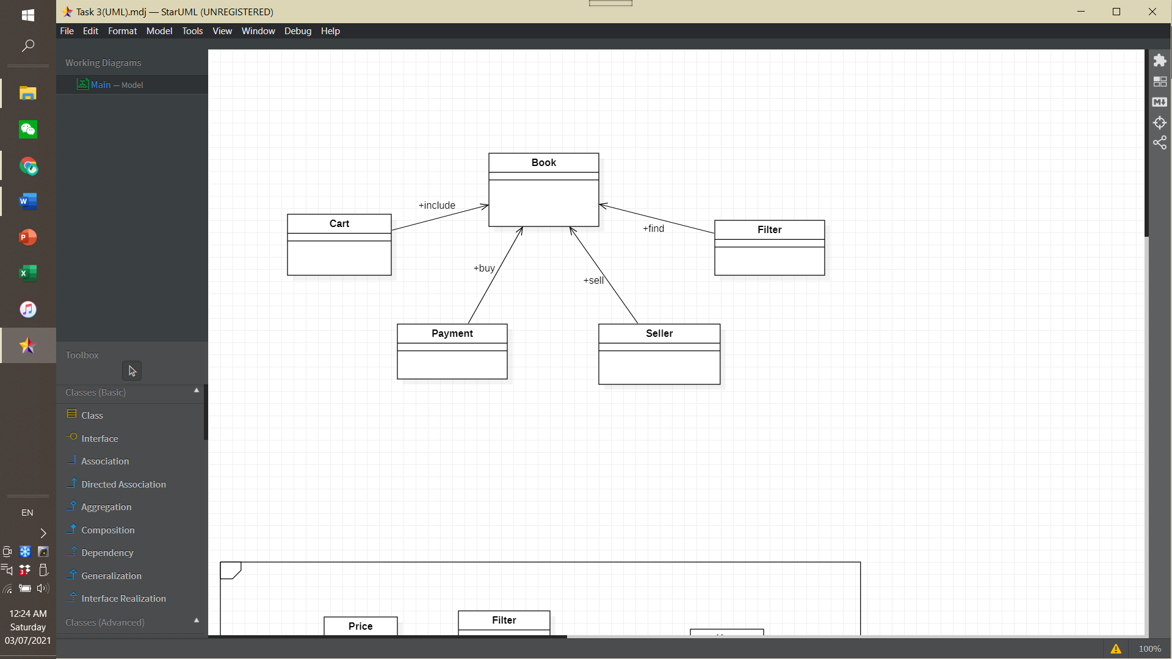

Class Responsibility

Cart – Book is included in cart. Cart as a shopping bag to collect the books that users want to purchase. Users would like to use cart to do payment fast and convenient.

Payment – Users would like to make payment for buying book. Users can choose different payment method via online platforms to buy their books. After users done payment, the books will be delivery to the address.

Seller – Users also as seller can sell their unuse books to others. Users would like to upload different information about the books for buyer to view and buy it. Seller can earn money and buyer get knowledges from books.

Filter – Users use filter to find their interested books. Filter helps users to search the book by different sector. It can save time and view more books in specific sector.

**Output2 – UML diagram with design pattern**

